A Taste of Data path + Control Design Example:
Factorial Circuit (Open Ended Lab)

LAB # 11


Spring 2024
CSE-308L Digital System Design Lab

Submitted by: Ali Asghar
Registration No.: 21PWCSE2059
Class Section: C

“On my honor, as student of University of Engineering and Technology, I have neither given nor received unauthorized assistance on this academic work.”

Submitted to:
Dr. Asif Ali Khan

Date:
1st June 2024

Department of Computer Systems Engineering
University of Engineering and Technology, Peshawar
Objectives:

To implement a circuit that calculates factorial of a number.

Software used:

Xilinx ISE

Block Diagram:
The datapath for calculating the factorial of an “N” bit number is given below. The datapath is controlled by a Finite State Machine (FSM). FSM generates signals Asel, Ale, Bsel and Ble at the correct times to operate the datapath. Input to FSM is a signal “Z” when Z=0 means the operation of the machine is complete and ANSWER can be read. The STG is also given in the following diagram.
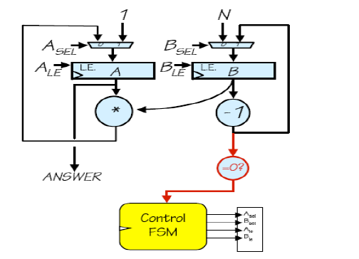
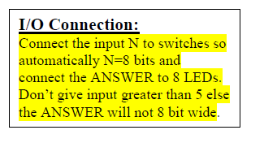
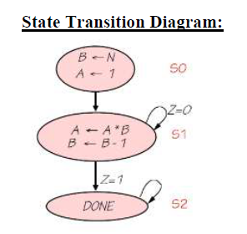

Lab Task 1:
Factorial Datapath + Control Path Simulation

Code:
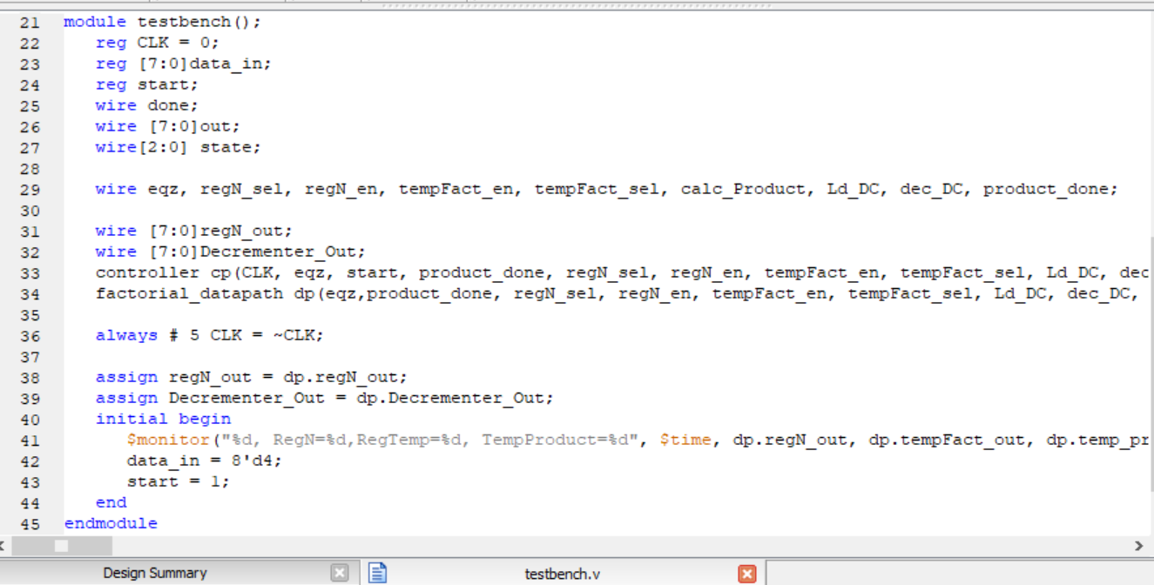
Figure 1.1 testbench module

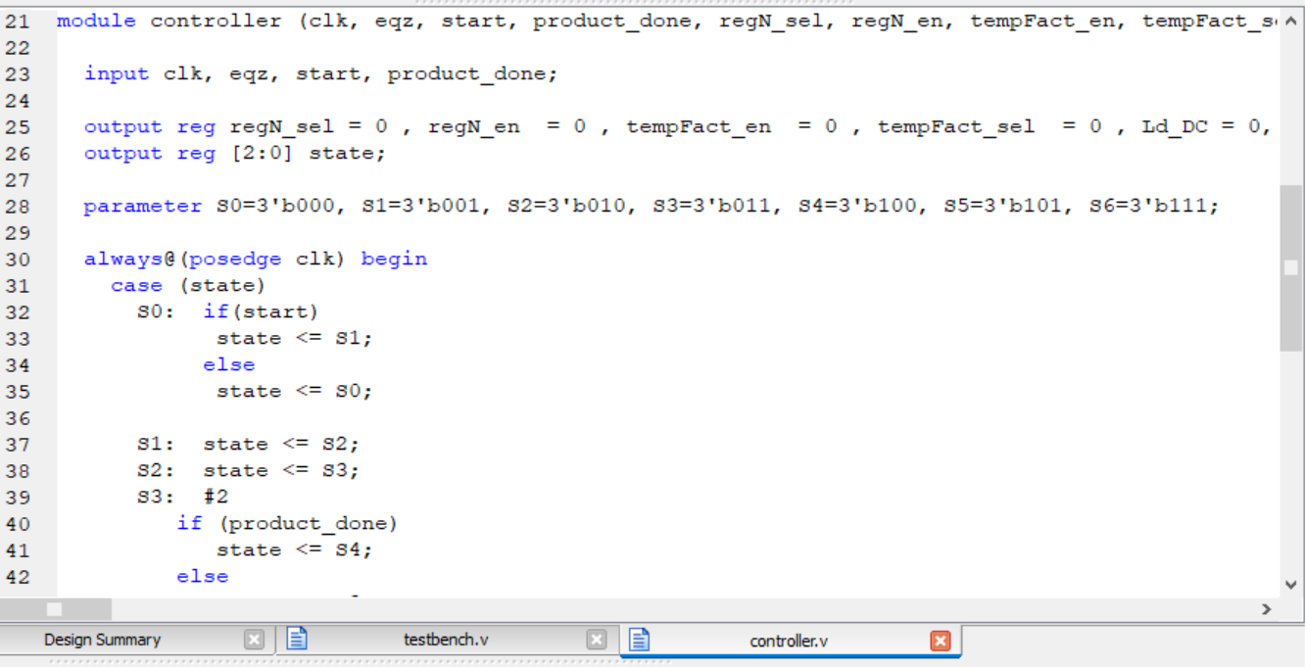
Figure 1.2.1: Control Path Code – Part 1
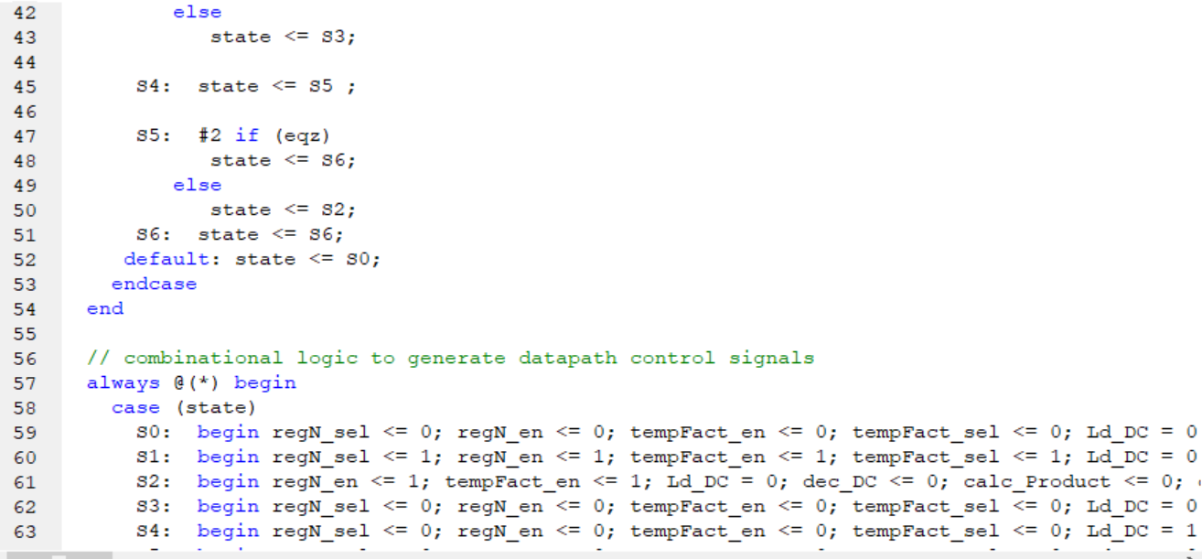
Figure 1.2.2: Control Path Code – Part 2

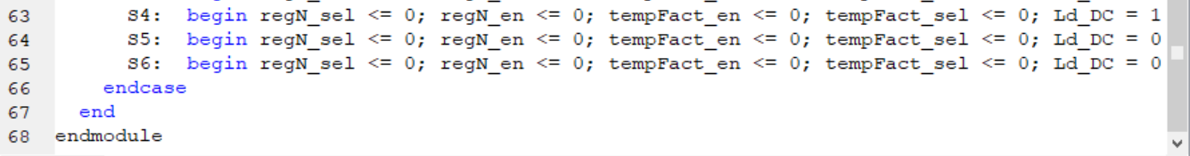
Figure 1.2.3: Control Path Code – Part 3

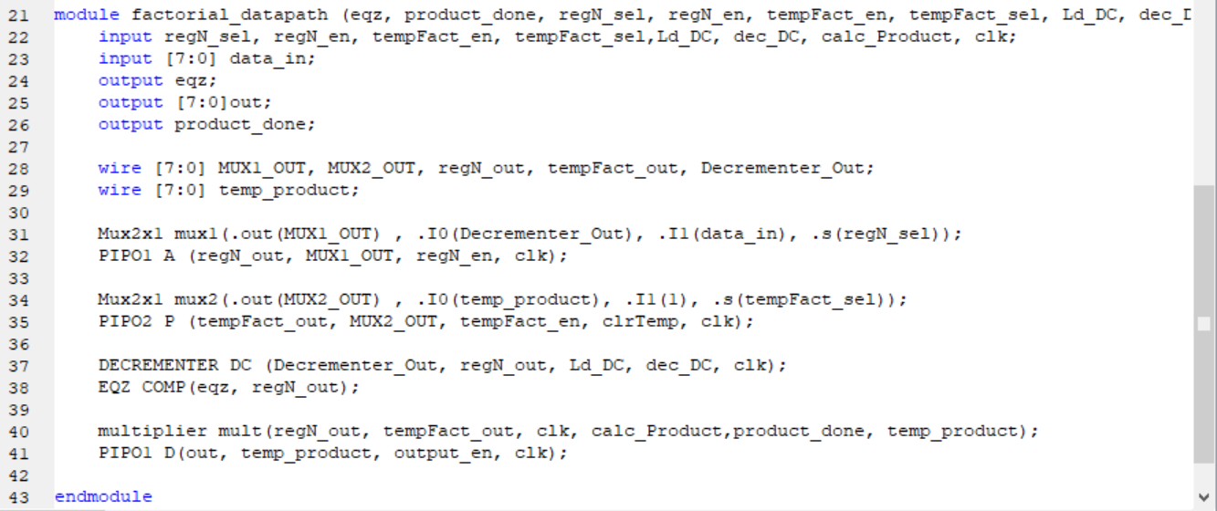
Figure 1.3: Factorial Datapath Code

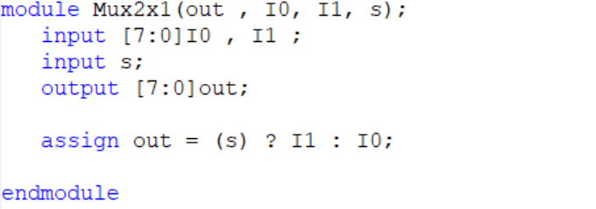
Figure 1.4: 2x1 Multiplexer Code

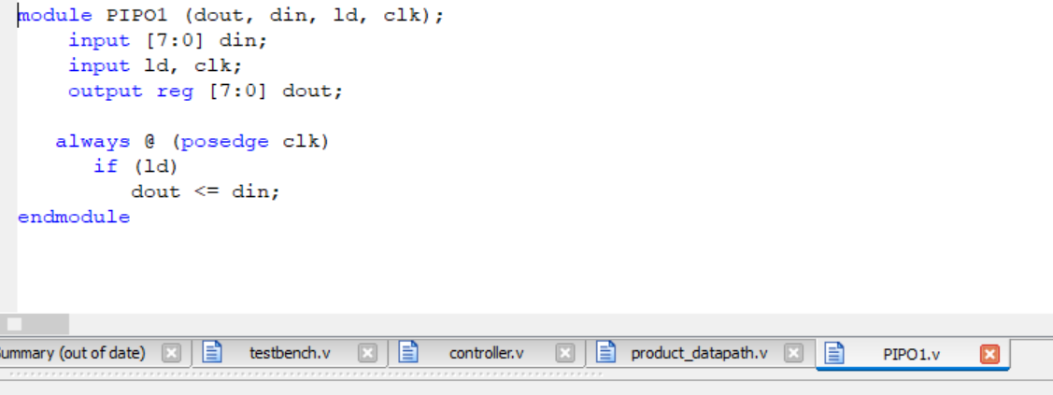
Figure 1.5: Parallel In Parallel Out (PIPO) Register 1 Code

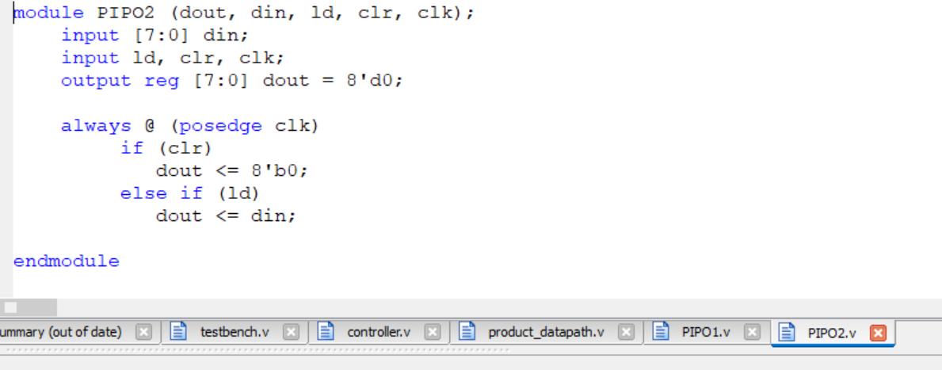
Figure 1.6: Parallel In Parallel Out (PIPO) Register 2 Code

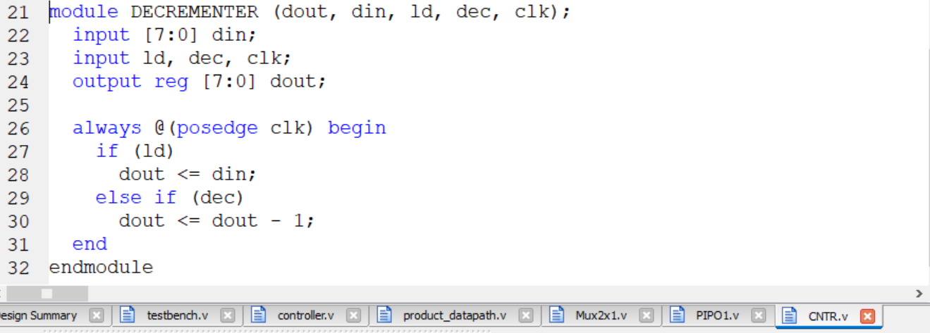
Figure 1.7: Decrementer Module Code

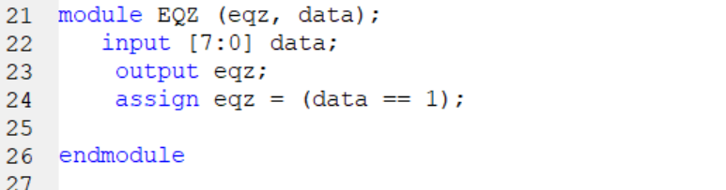
Figure 1.8: EQZ(Comparator) Module Code

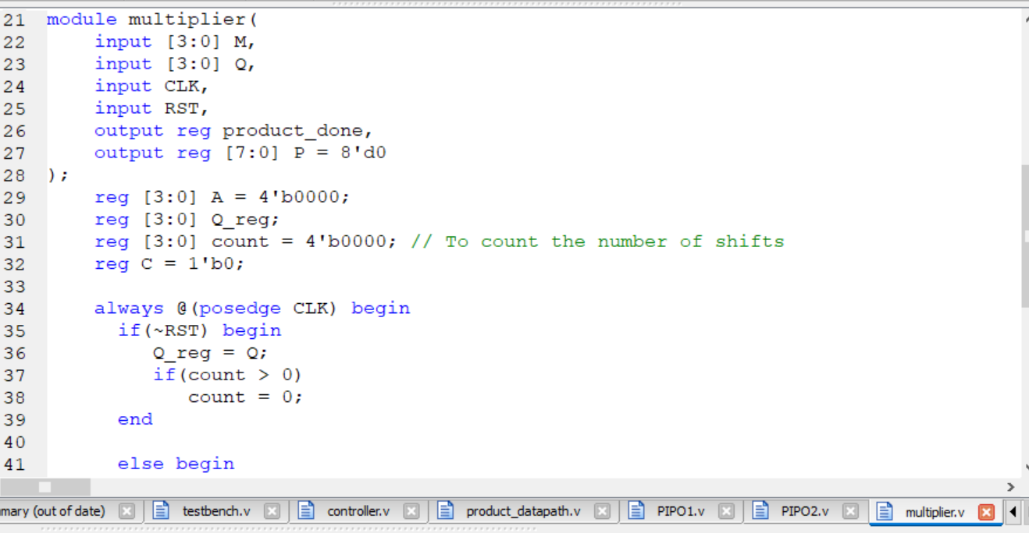
Figure 1.9.1: Unsigned 4-bit Multiplier Code – Part 1

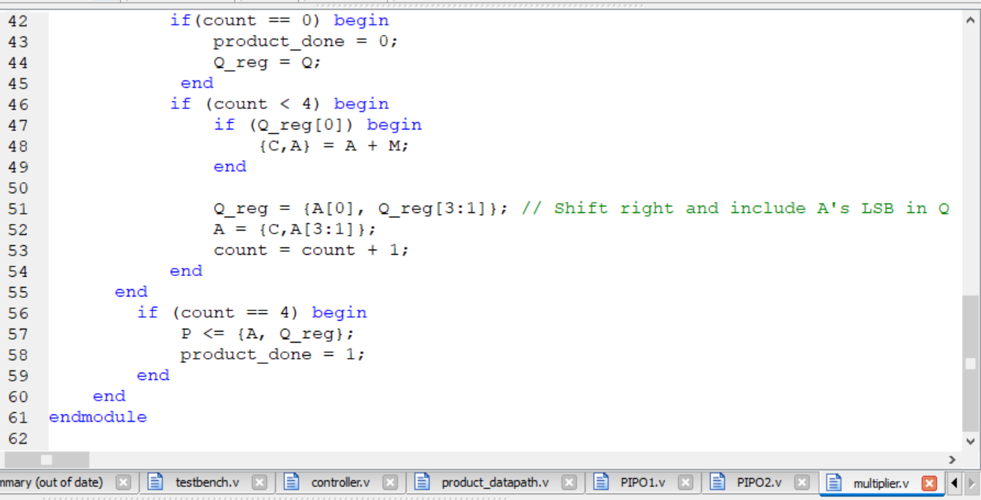
Figure 1.9.2: Unsigned 4-bit Multiplier Code – Part 2

Output:
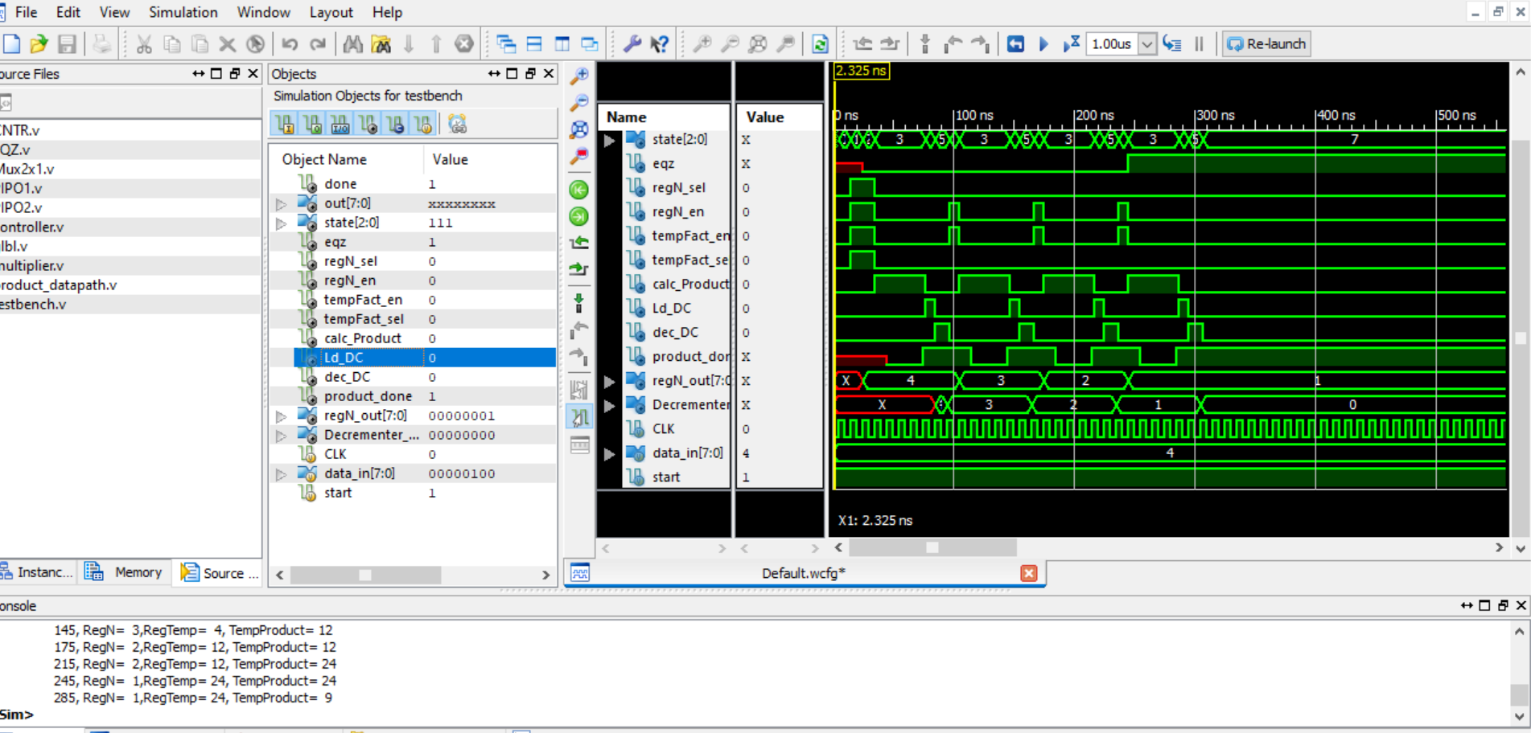
Figure 1.10: Output Waveform of Factorial Datapath and Control path using 4-bit Multiplier (Output is saved in RegTemp register)

Lab Task 2:
Product Datapath + Control Path Simulation

Code:
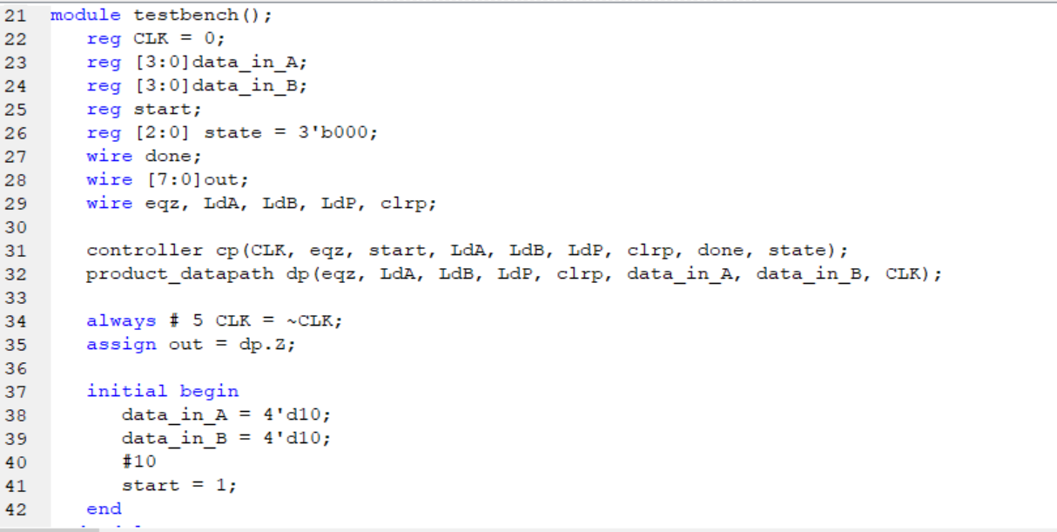
Figure 2.1 testbench module

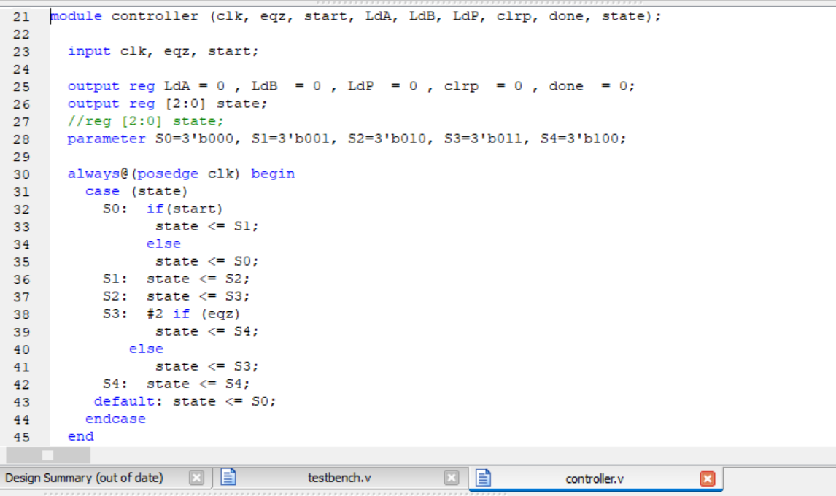
Figure 2.2.1: Product Control Path Code – Part 1

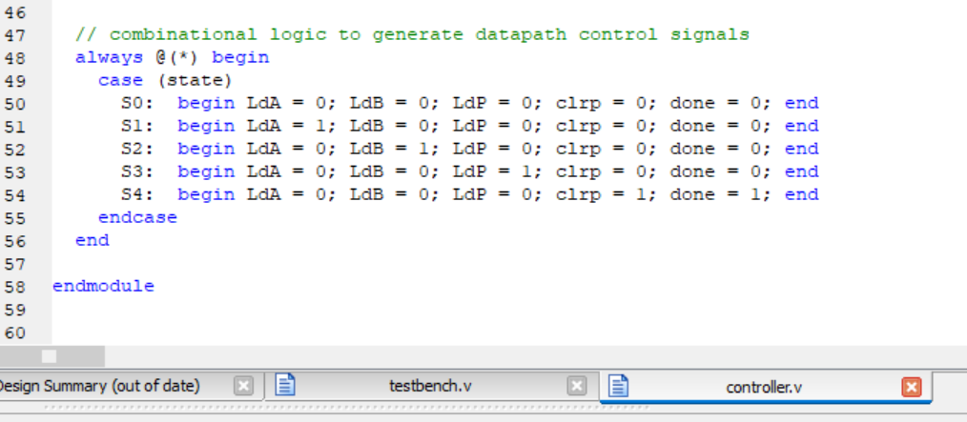
Figure 2.2.2: Product Control Path Code – Part 2

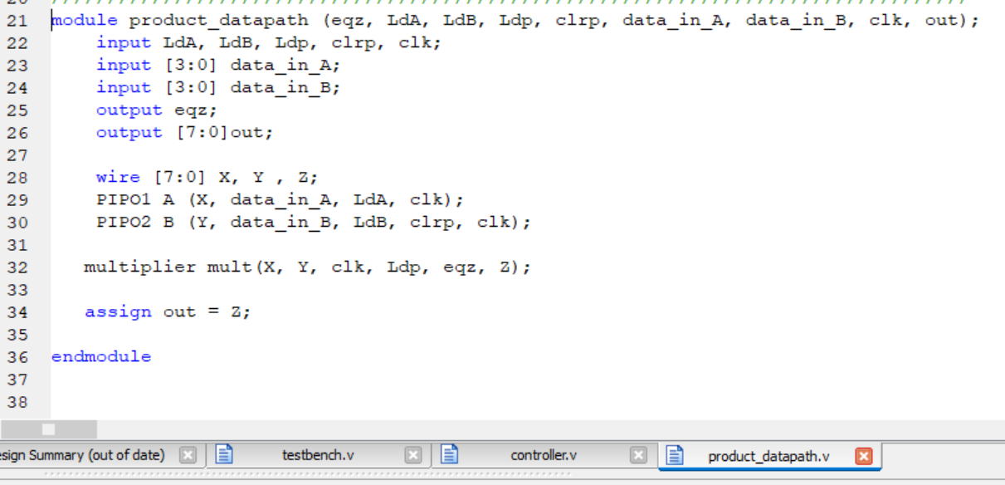
Figure 2.3: Product Datapath Code

Output:
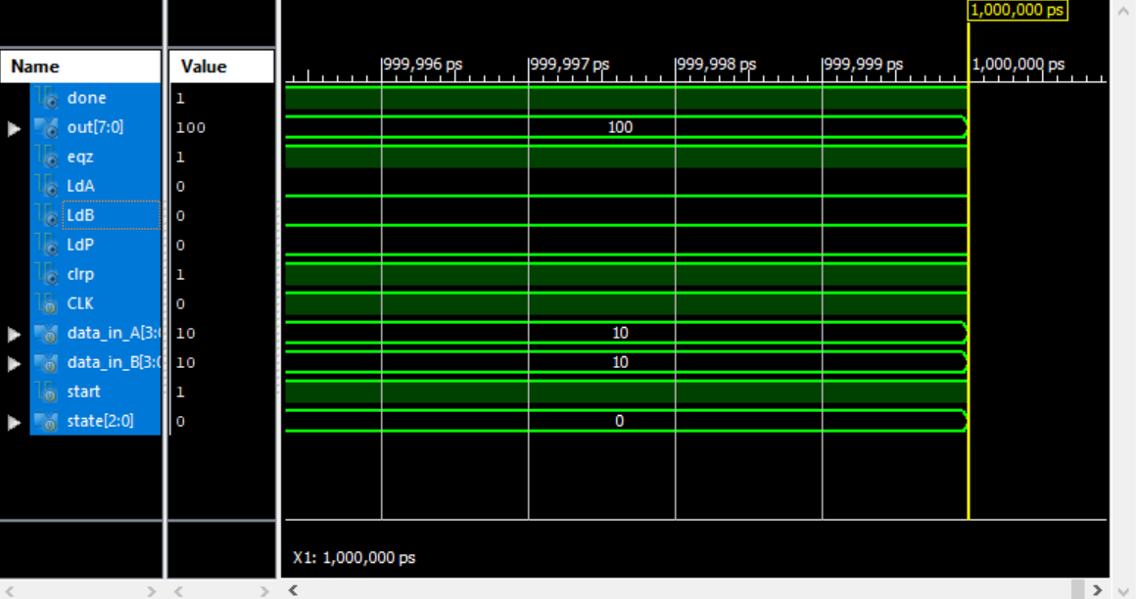
Figure 2.4: Output Waveform of Product Datapath and Control path using 4-bit Multiplier

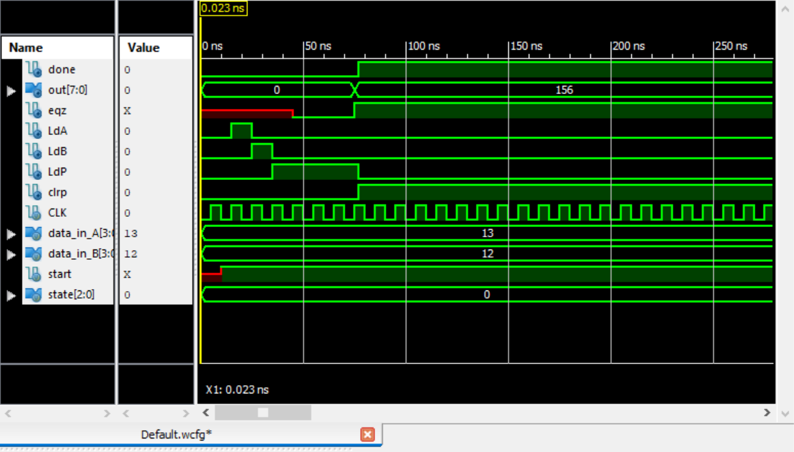
Figure 2.5: Output Waveform of Product Datapath and Control path using 4-bit Multiplier

